**Which network architecture functions through a combination of technologies that include wired, wireless, security, and more?**

**Cisco Borderless\***   
Cisco Enterprise Campus  
Cisco Enterprise Edge  
Cisco Enterprise Branch

**Which three network architectures have been introduced by Cisco to address the emerging technology challenges created by the evolving business models? (Choose three.)**

**Cisco Collaboration\***   
**Cisco Data Center\***   
**Cisco Borderless\***   
Cisco Enterprise Edge  
Cisco Enterprise Campus  
Cisco Enterprise Branch

**The network design for a college with users at five sites is being developed. Where in the campus network architecture would servers used by all users be located?**

services  
enterprise edge  
**data center\***   
access-distribution

**Fill in the blank. Use the abbreviation.**  
Under the Cisco Enterprise Edge module, the submodule that provides remote access  
including authentication and IPS appliances is the ” **VPN** ” and remote access submodule.

**What is creating a new challenge for IT departments by changing the border of the enterprise network?**

**tablets\***   
company-owned desktops  
energy costs  
access layer switching

**Which network architecture combines individual components to provide a comprehensive solution allowing people to cooperate and contribute to the production of something?**

Cisco Enterprise Campus Architecture  
Cisco Enterprise Branch Architecture  
Cisco Borderless Network Architecture  
**Cisco Collaboration Architecture\***

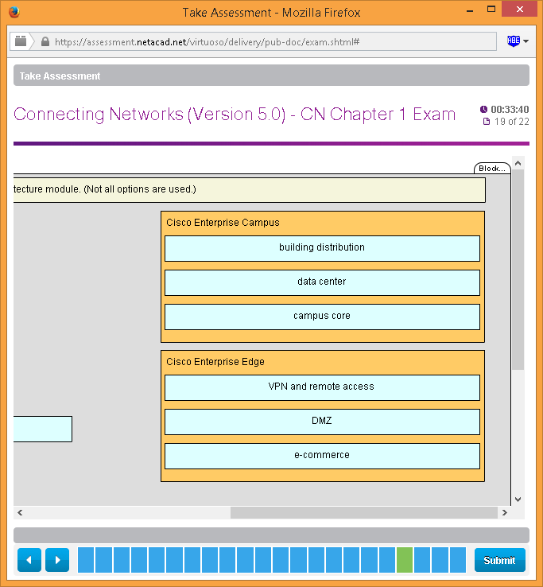

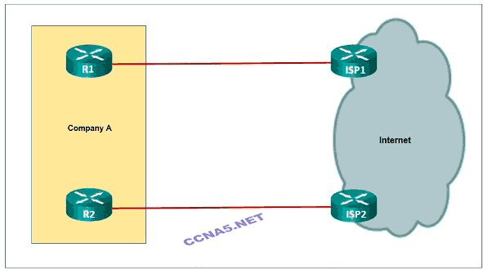  
**Refer to the exhibit. Which type of ISP connectivity to the service provider edge is being used by company A?**

dual-homed  
dual-multihomed  
single-homed  
**multihomed\***